Circumscribed Circle
# Source: AI Source: Provided by: [Data Path: Persons Table -> ID Column: 1, Name_En Column: Motasem Essam] -> From: [ChatGPT] on [7/25/2026]
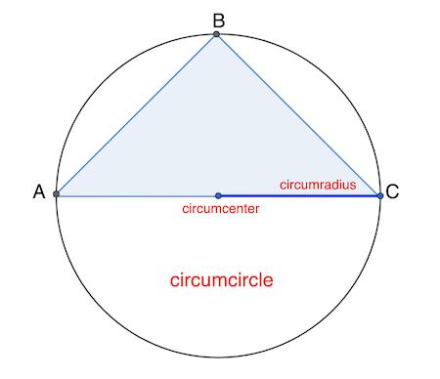
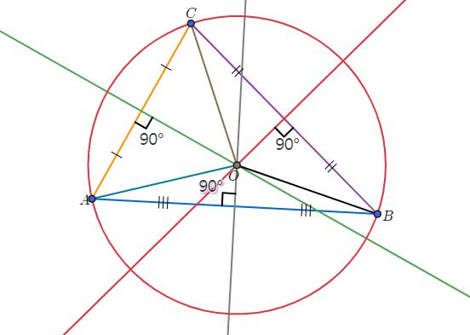
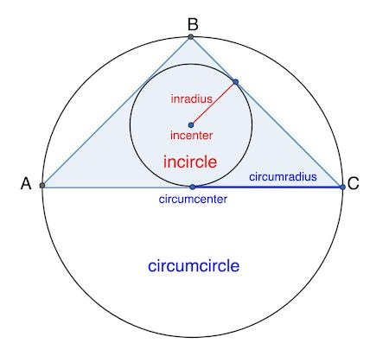
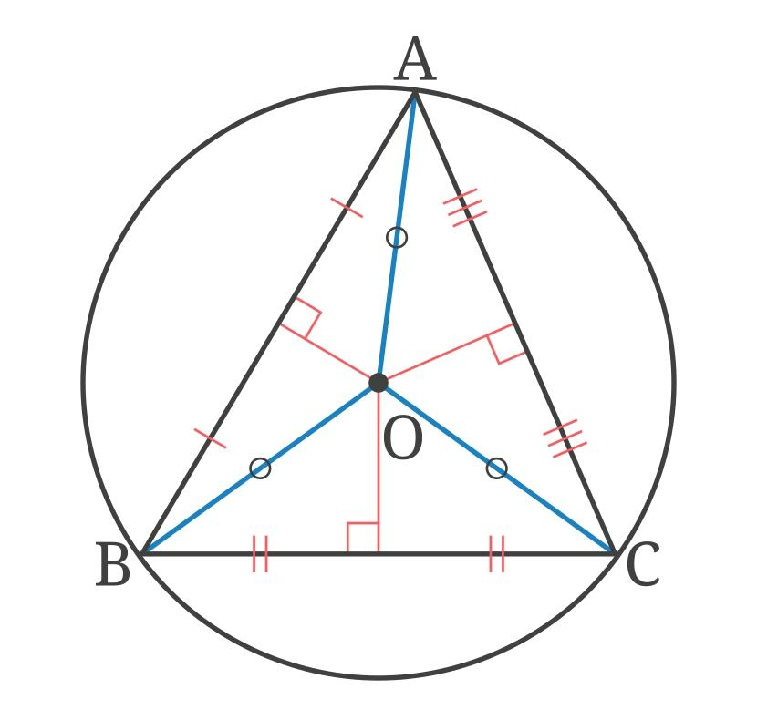
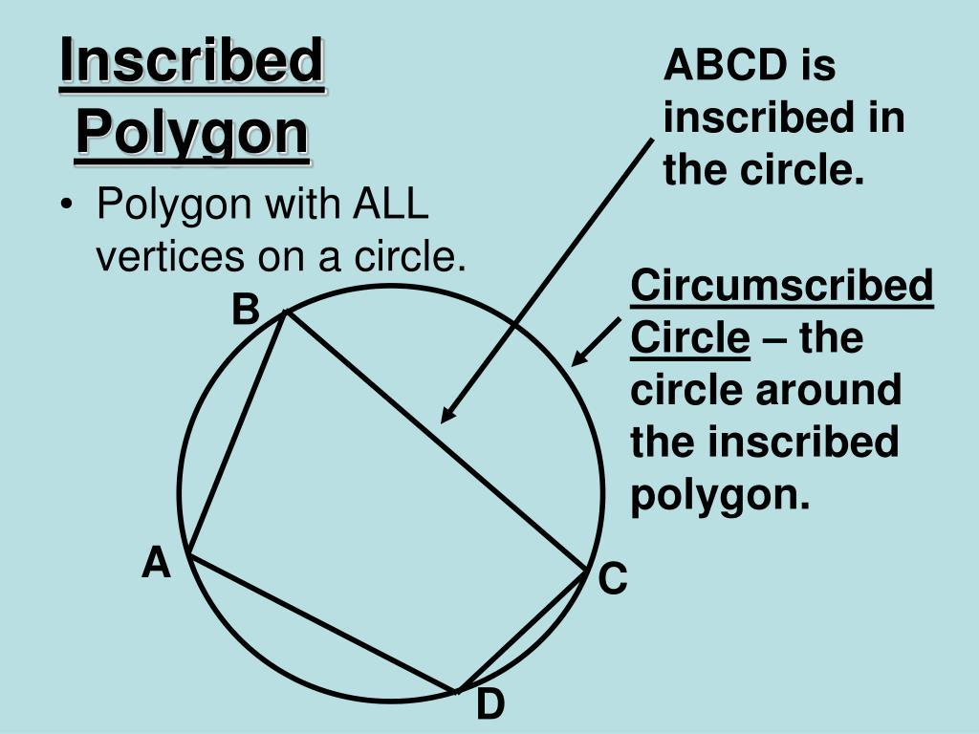

Definition
# Source: AI Source: Provided by: [Data Path: Persons Table -> ID Column: 1, Name_En Column: Motasem Essam] -> From: [ChatGPT] on [7/25/2026]
A Circumscribed Circle is a circle that passes through all the vertices of a polygon or other geometric figure.
In a triangle, the circumscribed circle is specifically called the Circumcircle.
The center of the circumscribed circle is called the Circumcenter.
For a triangle $ABC$, the circumcircle passes through:
$$A, B, C$$

Fundamental Concept
# Source: AI Source: Provided by: [Data Path: Persons Table -> ID Column: 1, Name_En Column: Motasem Essam] -> From: [ChatGPT] on [7/25/2026]
Consider a triangle $ABC$enclosed by a circle:
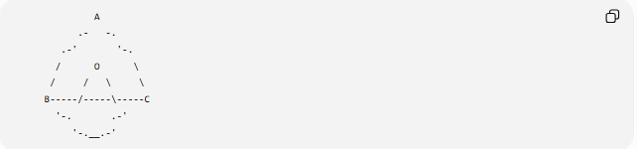
A
.- -.
.-' '-.
/ O \
/ / \ \
B-----/-----\-----C
'-. .-'
'-.__.-'
Where:
- $A,B,C$= vertices of the triangle
- $O$= circumcenter
- The outer circle = circumcircle
- $OA,OB,OC$= circumradii
Because all three vertices lie on the circle:
$$\boxed{OA=OB=OC=R}$$
where $R$is the circumradius.

Main Parts
# Source: AI Source: Provided by: [Data Path: Persons Table -> ID Column: 1, Name_En Column: Motasem Essam] -> From: [ChatGPT] on [7/25/2026]
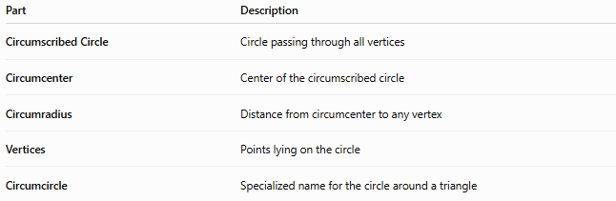
Part | Description
Circumscribed Circle | Circle passing through all vertices
Circumcenter | Center of the circumscribed circle
Circumradius | Distance from circumcenter to any vertex
Vertices | Points lying on the circle
Circumcircle | Specialized name for the circle around a triangle

Circumcenter
# Source: AI Source: Provided by: [Data Path: Persons Table -> ID Column: 1, Name_En Column: Motasem Essam] -> From: [ChatGPT] on [7/25/2026]
The Circumcenter is the center of the circumscribed circle.
For a triangle, it is the intersection of the perpendicular bisectors of the three sides.
$$\boxed{O=\text{intersection of the perpendicular bisectors}}$$
The circumcenter is equidistant from all three vertices:
$$\boxed{OA=OB=OC=R}$$

Circumradius
# Source: AI Source: Provided by: [Data Path: Persons Table -> ID Column: 1, Name_En Column: Motasem Essam] -> From: [ChatGPT] on [7/25/2026]
The radius of the circumcircle is called the Circumradius, usually denoted by $R$.
For triangle $ABC$:
$$\boxed{R=OA=OB=OC}$$
The circumradius depends on the size and shape of the triangle.

Circumcircle of a Triangle
# Source: AI Source: Provided by: [Data Path: Persons Table -> ID Column: 1, Name_En Column: Motasem Essam] -> From: [ChatGPT] on [7/25/2026]
Every non-degenerate triangle has exactly one circumcircle.
The three vertices determine the circle uniquely.
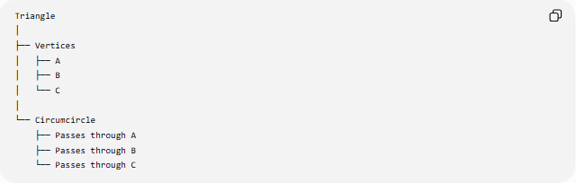
Triangle
│
├── Vertices
│ ├── A
│ ├── B
│ └── C
│
└── Circumcircle
├── Passes through A
├── Passes through B
└── Passes through C

Construction of a Circumcircle
# Source: AI Source: Provided by: [Data Path: Persons Table -> ID Column: 1, Name_En Column: Motasem Essam] -> From: [ChatGPT] on [7/25/2026]
The circumcircle of a triangle can be constructed using the perpendicular bisectors of its sides.
Procedure
- Draw the triangle.
- Construct the perpendicular bisector of side $AB$.
- Construct the perpendicular bisector of side $BC$.
- Their intersection is the circumcenter $O$.
- Draw a circle centered at $O$through any vertex.
Because:
$$OA=OB=OC$$
the circle passes through all three vertices.

Position of the Circumcenter
# Source: AI Source: Provided by: [Data Path: Persons Table -> ID Column: 1, Name_En Column: Motasem Essam] -> From: [ChatGPT] on [7/25/2026]
The position of the circumcenter depends on the type of triangle.
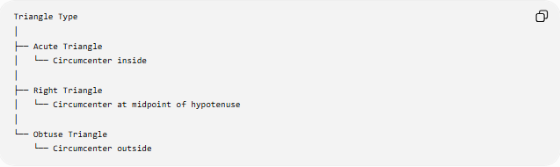
Triangle Type
│
├── Acute Triangle
│ └── Circumcenter inside
│
├── Right Triangle
│ └── Circumcenter at midpoint of hypotenuse
│
└── Obtuse Triangle
└── Circumcenter outside
Acute Triangle
The circumcenter lies inside the triangle.
Right Triangle
The circumcenter lies at the midpoint of the hypotenuse.
Therefore:
$$\boxed{R=\frac{c}{2}}$$
where $c$is the hypotenuse.
Obtuse Triangle
The circumcenter lies outside the triangle.

Circumradius Formula
# Source: AI Source: Provided by: [Data Path: Persons Table -> ID Column: 1, Name_En Column: Motasem Essam] -> From: [ChatGPT] on [7/25/2026]
For a triangle with side lengths $a,b,c$and area $A$:
$$\boxed{R=\frac{abc}{4A}}$$
This is one of the principal formulas for the circumradius.

Circumradius Using an Angle
# Source: AI Source: Provided by: [Data Path: Persons Table -> ID Column: 1, Name_En Column: Motasem Essam] -> From: [ChatGPT] on [7/25/2026]
If side $a$is opposite angle $A$:
$$\boxed{a=2R\sin{A}}$$
Therefore:
$$\boxed{R=\frac{a}{2\sin{A}}}$$
Similarly:
$$R=\frac{b}{2\sin{B}}$$
and:
$$R=\frac{c}{2\sin{C}}$$
This relationship is part of the Law of Sines.

Example
# Source: AI Source: Provided by: [Data Path: Persons Table -> ID Column: 1, Name_En Column: Motasem Essam] -> From: [ChatGPT] on [7/25/2026]
Suppose a triangle has:
$$a=6, b=8, c=10$$
Since:
$$6^{2}+8^{2}={10}^{2}$$
the triangle is right-angled.
For a right triangle, the circumcenter is the midpoint of the hypotenuse.
Therefore:
$$R=\frac{10}{2} \\ \boxed{R=5}$$

Circumcircle and Central Angles
# Source: AI Source: Provided by: [Data Path: Persons Table -> ID Column: 1, Name_En Column: Motasem Essam] -> From: [ChatGPT] on [7/25/2026]
The radii from the circumcenter to two vertices form a central angle.
For example:
$$∠AOB$$
is a central angle corresponding to arc $\hat{AB}$.
The relationship between the central angle and an inscribed angle subtending the same arc is:
$$\boxed{m\left(∠AOB\right)=2m\left(∠ACB\right)}$$

Circumcircle and Inscribed Angles
# Source: AI Source: Provided by: [Data Path: Persons Table -> ID Column: 1, Name_En Column: Motasem Essam] -> From: [ChatGPT] on [7/25/2026]
The vertices of the triangle lie on the circumcircle, so the triangle itself is an inscribed triangle.
Its angles are therefore inscribed angles of the circumcircle.
For example:
$$∠ACB$$
intercepts arc $\hat{AB}$, so:
$$\boxed{m\left(∠ACB\right)=\frac{1}{2}m\left(\hat{AB}\right)}$$

Circumcircle and Chords
# Source: AI Source: Provided by: [Data Path: Persons Table -> ID Column: 1, Name_En Column: Motasem Essam] -> From: [ChatGPT] on [7/25/2026]
Every side of an inscribed triangle is a chord of its circumcircle.
Thus:
$$\boxed{AB, BC, CA}$$
are all chords of the circumcircle.
A diameter is a special chord passing through the circumcenter.

Circumscribed Circle and Inscribed Circle
# Source: AI Source: Provided by: [Data Path: Persons Table -> ID Column: 1, Name_En Column: Motasem Essam] -> From: [ChatGPT] on [7/25/2026]
These two concepts are closely related but have opposite relationships with a triangle.
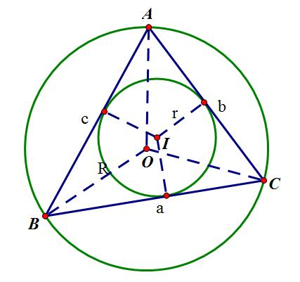
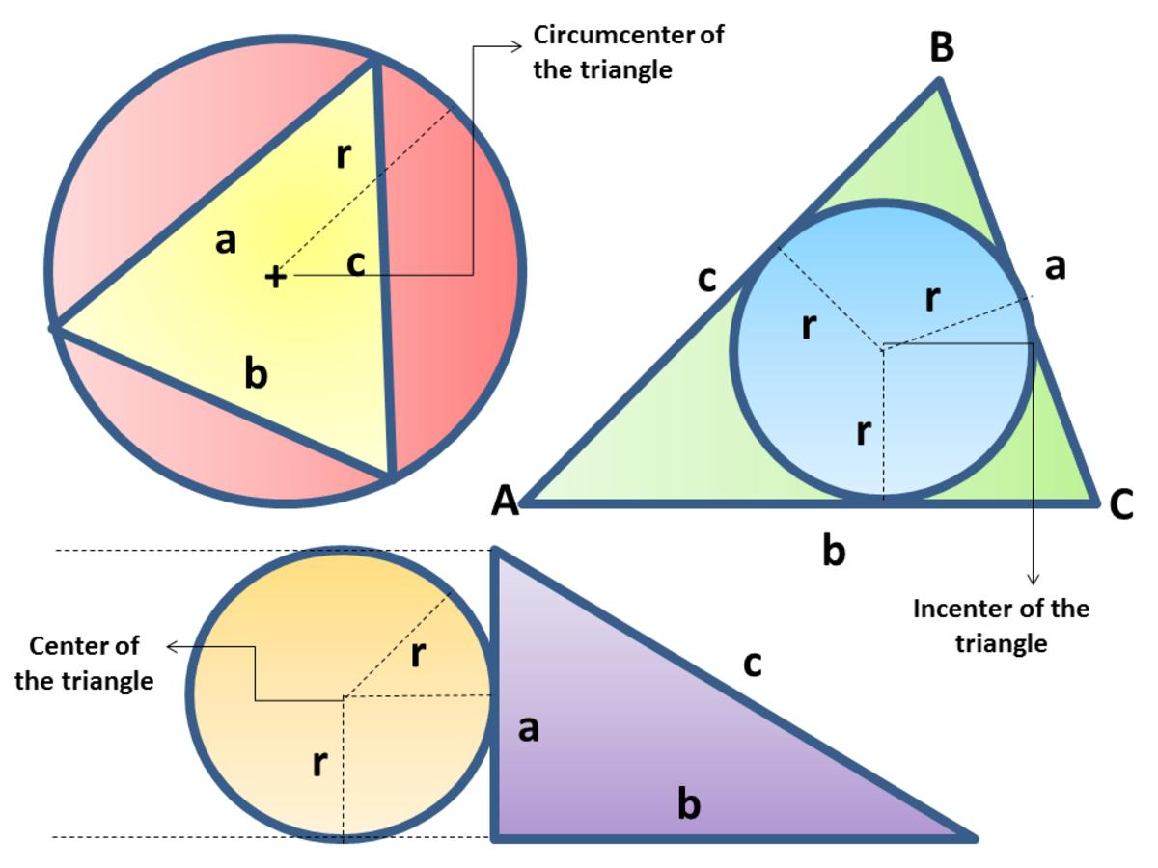
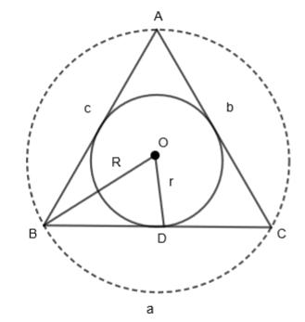
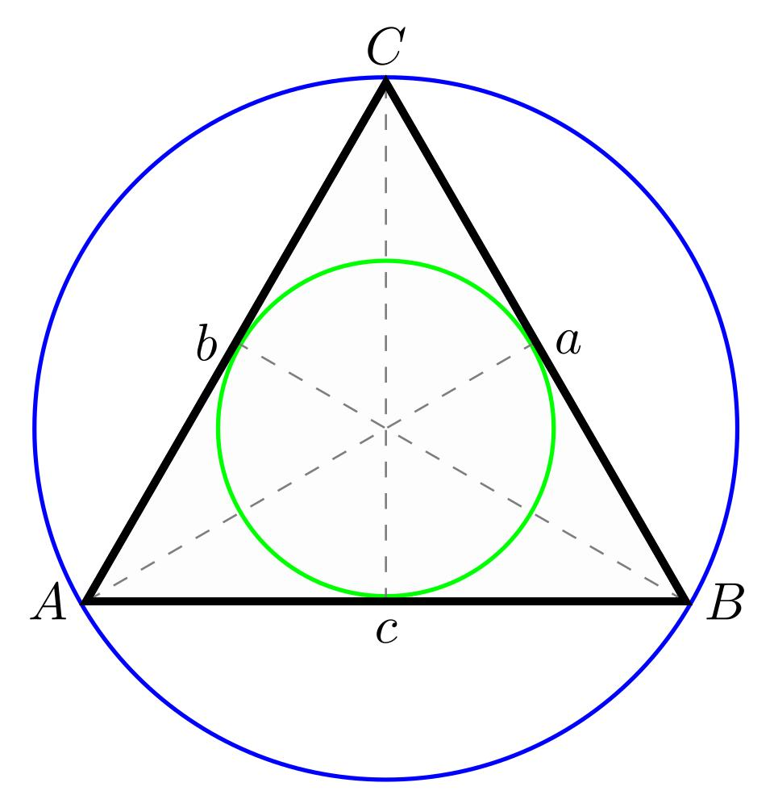
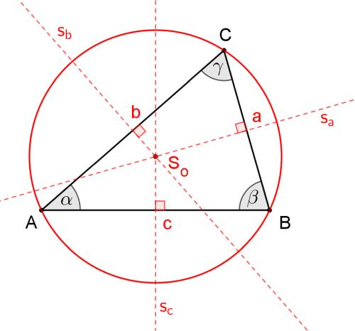
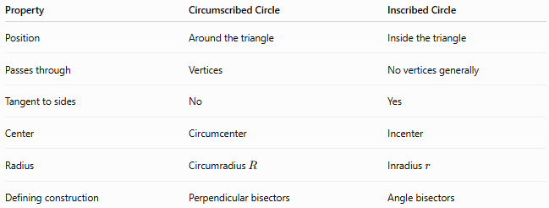
Property | Circumscribed Circle | Inscribed Circle
Position | Around the triangle | Inside the triangle
Passes through | Vertices | No vertices generally
Tangent to sides | No | Yes
Center | Circumcenter | Incenter
Radius | Circumradius $R$ | Inradius $r$
Defining construction | Perpendicular bisectors | Angle bisectors

Special Cases

Equilateral Triangle
# Source: AI Source: Provided by: [Data Path: Persons Table -> ID Column: 1, Name_En Column: Motasem Essam] -> From: [ChatGPT] on [7/25/2026]
For an equilateral triangle with side length $a$:
$$\boxed{R=\frac{\sqrt{3}}{3}a}$$
and:
$$\boxed{r=\frac{\sqrt{3}}{6}a}$$
Therefore:
$$\boxed{R=2r}$$
The circumcenter and incenter coincide.

Right Triangle
# Source: AI Source: Provided by: [Data Path: Persons Table -> ID Column: 1, Name_En Column: Motasem Essam] -> From: [ChatGPT] on [7/25/2026]
For a right triangle:
$$\boxed{R=\frac{c}{2}}$$
The circumcenter is the midpoint of the hypotenuse.

Obtuse Triangle
# Source: AI Source: Provided by: [Data Path: Persons Table -> ID Column: 1, Name_En Column: Motasem Essam] -> From: [ChatGPT] on [7/25/2026]
The circumcenter lies outside the triangle, but the circumcircle still passes through all three vertices.

Circumscribed Circle of a Regular Polygon
# Source: AI Source: Provided by: [Data Path: Persons Table -> ID Column: 1, Name_En Column: Motasem Essam] -> From: [ChatGPT] on [7/25/2026]
Every regular polygon has a circumscribed circle.
The circle passes through all the polygon's vertices.
Its center is the polygon's center.
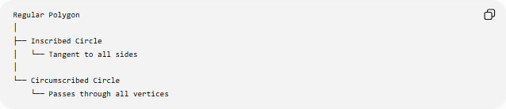
Regular Polygon
│
├── Inscribed Circle
│ └── Tangent to all sides
│
└── Circumscribed Circle
└── Passes through all vertices
For a regular polygon with side length $a$and $n$sides:
$$\boxed{R=\frac{a}{2sin⁡\left(\frac{{180}^{∘}}{n}\right)}}$$

Classification
# Source: AI Source: Provided by: [Data Path: Persons Table -> ID Column: 1, Name_En Column: Motasem Essam] -> From: [ChatGPT] on [7/25/2026]
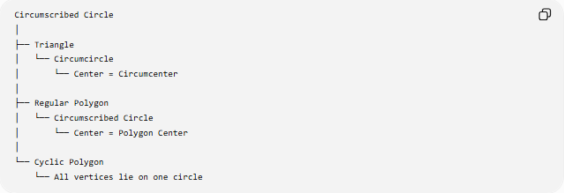
Circumscribed Circle
│
├── Triangle
│ └── Circumcircle
│ └── Center = Circumcenter
│
├── Regular Polygon
│ └── Circumscribed Circle
│ └── Center = Polygon Center
│
└── Cyclic Polygon
└── All vertices lie on one circle
A polygon whose vertices all lie on one circle is called a Cyclic Polygon.

Important Relationships
# Source: AI Source: Provided by: [Data Path: Persons Table -> ID Column: 1, Name_En Column: Motasem Essam] -> From: [ChatGPT] on [7/25/2026]
Equal Radii
$$\boxed{OA=OB=OC=R}$$
Circumradius
$$\boxed{R=\frac{abc}{4A}}$$
Extended Law of Sines
$$\boxed{\frac{a}{\sin{A}}=\frac{b}{\sin{B}}=\frac{c}{\sin{C}}=2R}$$
Right Triangle
$$\boxed{R=\frac{c}{2}}$$
Equilateral Triangle
$$\boxed{R=\frac{\sqrt{3}}{3}a}$$

Key Points
# Source: AI Source: Provided by: [Data Path: Persons Table -> ID Column: 1, Name_En Column: Motasem Essam] -> From: [ChatGPT] on [7/25/2026]
- A Circumscribed Circle passes through all the vertices of a figure.
- For a triangle, it is called the Circumcircle.
- Its center is the Circumcenter.
- Its radius is the Circumradius.
- The circumcenter is the intersection of the perpendicular bisectors of the triangle's sides.
- Every non-degenerate triangle has exactly one circumcircle.
- In an acute triangle, the circumcenter is inside.
- In a right triangle, it is at the midpoint of the hypotenuse.
- In an obtuse triangle, it is outside.
- Every regular polygon has a circumscribed circle.
- A polygon whose vertices lie on a common circle is a cyclic polygon.

Conclusion
# Source: AI Source: Provided by: [Data Path: Persons Table -> ID Column: 1, Name_En Column: Motasem Essam] -> From: [ChatGPT] on [7/25/2026]
A Circumscribed Circle is a circle that passes through all the vertices of a geometric figure. In a triangle, it is called the Circumcircle, its center is the Circumcenter, and its radius is the Circumradius. The concept is fundamental to cyclic polygons, inscribed angles, chords, central angles, perpendicular bisectors, and triangle geometry.
Would you like a simple diagram showing where the circumcenter lies in acute, right, and obtuse triangles?

